8.98: The two fragments are 3.00 kg and 9.00 kg. Time to reach maximum height = time to fall back to the ground.
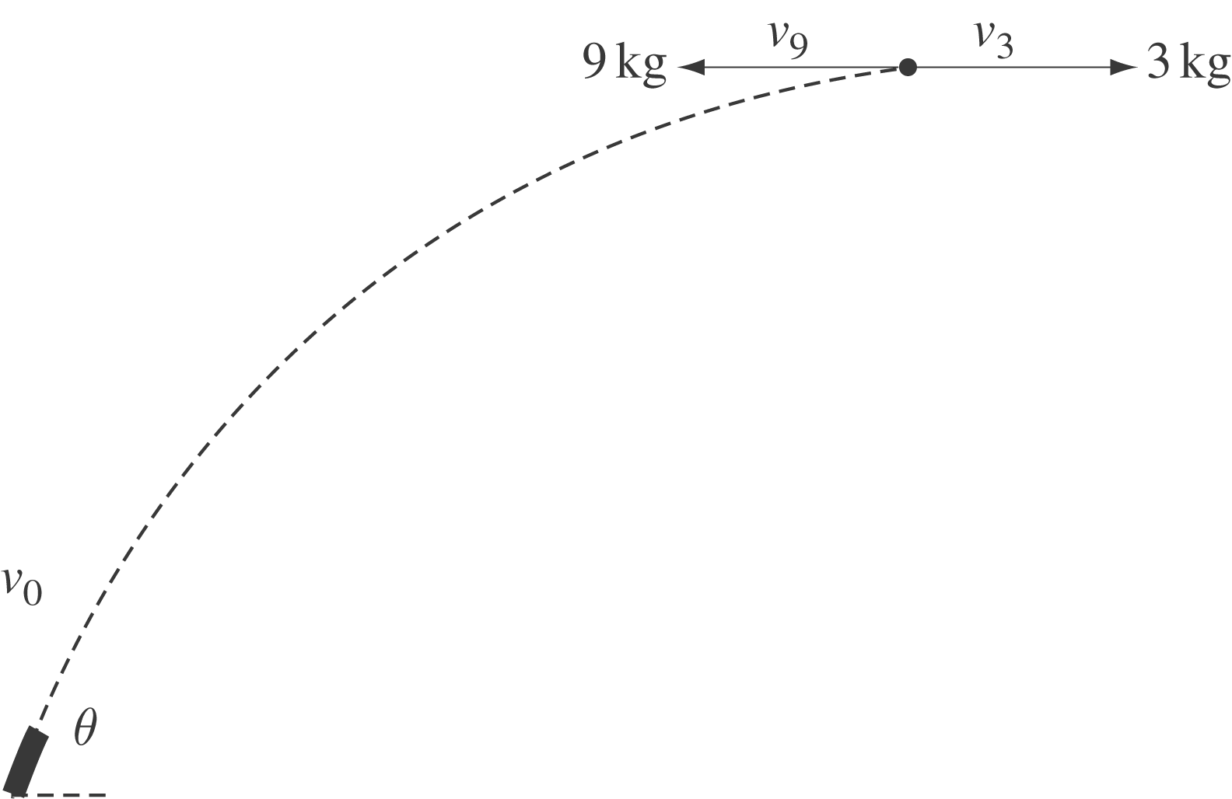
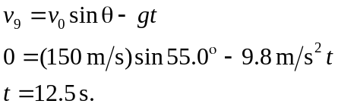

The heavier fragment travels back to its starting point, so it reversed its velocity.
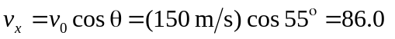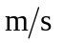to the left after the explosion; this is 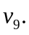Now get 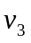 using momentum conversation.
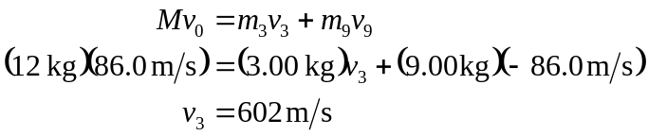
Energy released = Energy after explosion – Energy before explosion

